Task 2

1. How to create multiple sub directories within a parent directory?

Sol: Parent directory is pad and sub directory are rock1 rock2 rock3 rock4 rock5.

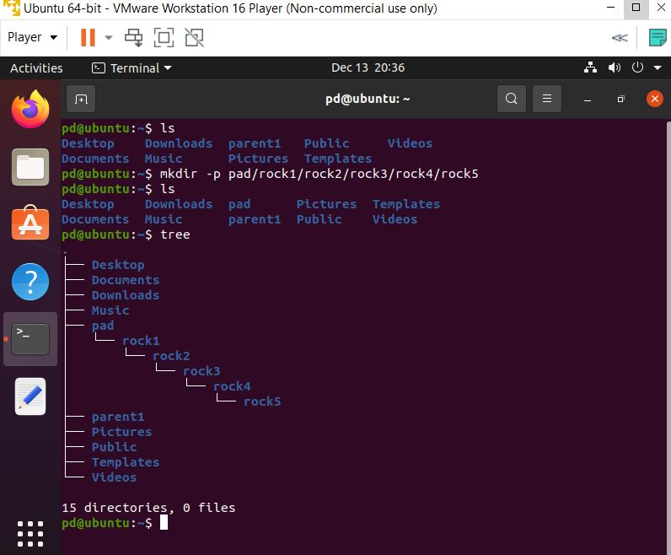

1. Explore the command with command at least 2 flags with the help of --help or using man?

Sol:

1. (ls –a) : It shows all the files and including hidden .



1. (ls –R) : It shows all the directory and contents recursively .

